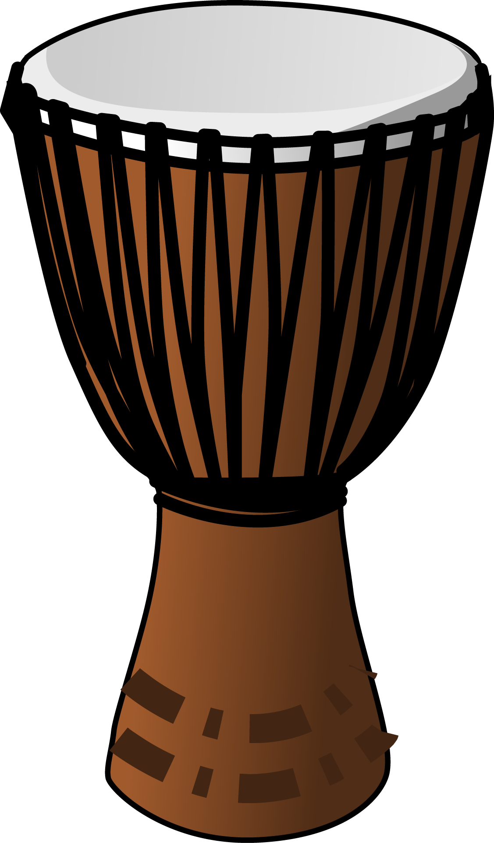
MUSIC – Web Quest:
Origins, Facts and Uses of the Djembe

Name __________________________________________
Source: Open ClipArt.

Using Google.com search feature … find out what you can about the African djembe drum. Fill out this pro forma and save it in your student public personal folder as WebQuest Djembe _YourName.

Laptop Login: wanguri.barra Laptop Password: Wanguri
- What does the word Djembe mean?

- There is a story circulating about the “true inventor” of the Djembe. The djembe looks a lot like the tool she was using. What was that tool?

- What two west African countries are said to have originated or “invented” the djembe?

- In Africa, what is the djembe used for?

- What are they made of?

- List another cool fact you found out about the djembe, or paste in a picture you found from Google. Hint when searching Google select images on the left hand side menu.

Tips:
- suggested search terms: djembe origin history uses
- Vary Google: using AND , OR , “EXACT PHRASE” when searching Google http://google.about.com/od/searchingtheweb/qt/booleantip.htm
- Useful websites: http://en.wikipedia.org/wiki/Djembe | http://www.african-music-safari.com/djembe-history.html

