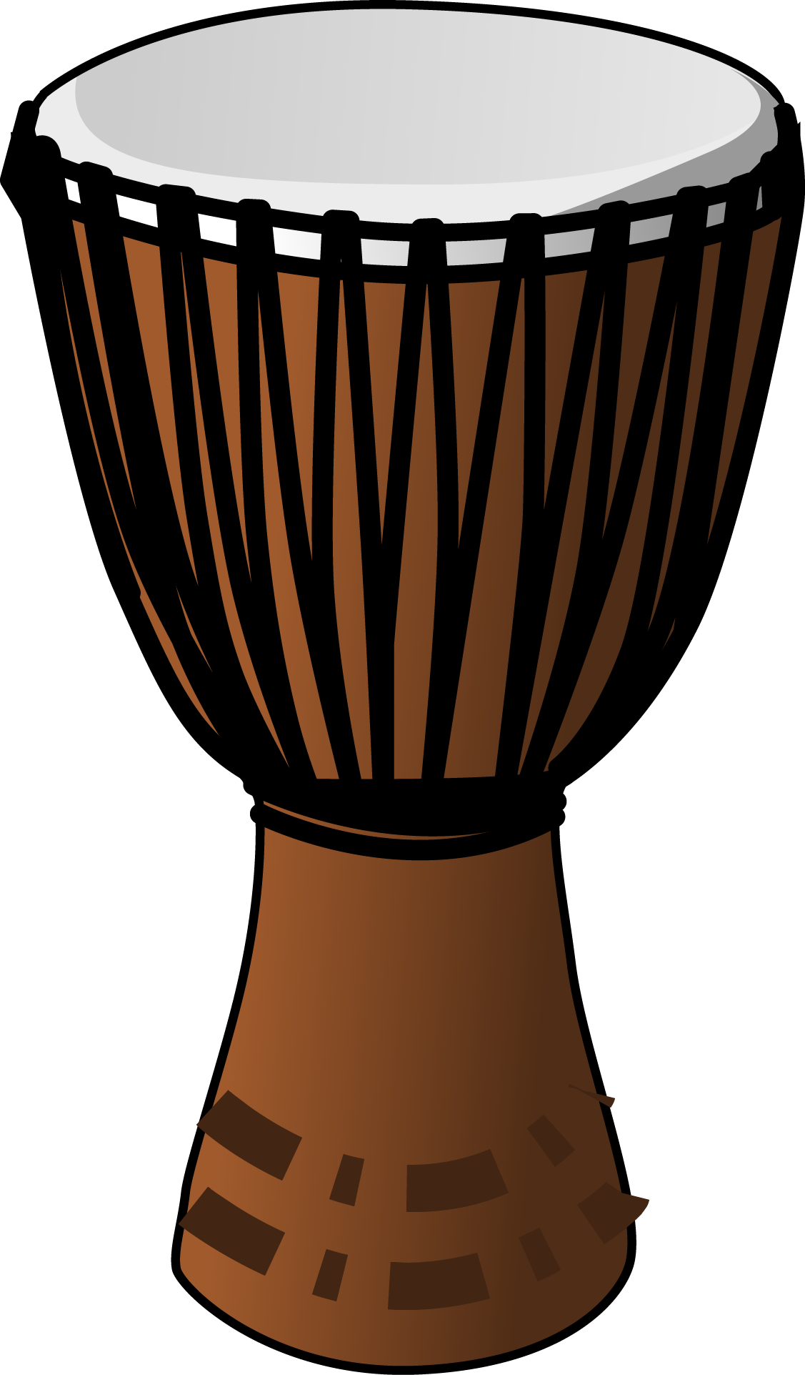
MUSIC – Web Quest Answer Key:
Origins, Facts and Uses of the Djembe

Name __________________________________________
Source: Open ClipArt.

Using Google.com search feature … find out what you can about the African djembe drum. Fill out this pro forma and save it in your student public personal folder as WebQuest Djembe _YourName.
- What does the word Djembe mean?

Gather together in peace and/or “tree and goat”

- There is a story circulating about the “true inventor” of the Djembe. The djembe looks a lot like the tool she was using. What was that tool?

A Mortar

- What two west African countries are said to have originated or “invented” the djembe?

Mali and Guinea

- In Africa, what is the djembe used for?
Special ceremonies, weddings funerals, gatherings, and now modern music
- What are they made of?
Wood and goat skin, sometimes with fur

- List another cool fact you found out about the djembe, or paste in a picture you found from Google. Hint when searching Google select images on the left hand side menu.
Open Ended Answer

Tips:
Suggested search terms: djembe, origin, history, uses

Vary Google: using AND, OR, 'EXACT PHRASE' when searching Google http://google.about.com/od/searchingtheweb/qt/booleantip.htm
Useful websites: http://en.wikipedia.org/wiki/Djembe | http://www.african-music-safari.com/djembe-history.html

